Q1. [50 points] Functional Dependency (FDs)

- [ 15 points] What are properties of a good/bad database design? What is a functional dependency (FD)? What are the possible sources of information that defines the FDs that holds among the attributes of a relational schema? [ Hints : see from lecture slides]

Properties of good/bad database design
- Should accommodate your data processing and reporting needs.
- Should help support and ensure accuracy and integrity of your information.
- Should divide your information in subject based to reduce redundant data.
- Should provide access with the information it requires to join the information in the tables together as needed.
Functional dependency (FD)
It is a constraint that determines the relation of one attribute to another in database management system.it exist between primary key and non-key attribute within a table.
Sources of information that defines the FDs that hold among attributes of a relational schema.
- Given M as set of attributes and N as a subset of M, then M holds a value of N
- When M->N holds, and c is attribute set then ac->bc also holds
- In algebra if M->N holds and N->O holds, then M->O also holds

- [ 20 points] Ruling Out FDs: Given a relation “MyTinyStore”. Which FDs may exist in this relation? What do you need to rule out?

MyTinyStore
Customer_LastName | Drink_Item | Food_Item | Delivery_method
Smith | Iced_Tea | Burger | Not_Delivery
Smith | Coke | Hot Dog | Delivery
Paul | Coke | Hot Dog | Carry out
Sara | Coffee | Noodles | Carry out

FD1: Customer_lastname, Drink_item -> food_item, delivery_method (partial functional dependency, key candidate, transitive dependency to underlined dependency)
FD2: Customer_lastname, Drink_item, food_item -> delivery_method (partial functional dependency, key candidate)
FD3: Customer_lastname, Drink_item, delivery_method -> food_item (partial functional dependency, key candidate)
FD4: Customer_lastname, food_item -> Drink_item (partial functional dependency, key candidate, transitive dependency to underlined dependency
FD5: Customer_lastname, food_item, delivery_method -> Drink_item (partial functional dependency, key candidate)
FD6: Customer_lastname, delivery_method -> food_item (partial functional dependency, key candidate, transitive dependency to underlined dependency)
FD7: Drink_item -> food_item (full functional dependency)
FD8: Drink_item, food_item -> Customer_lastname (partial functional dependency, key candidate)
FD9: Drink_item, delivery_method -> Customer_lastname, food_item (partial functional dependency, key candidate)
FD10: food_item -> Drink_item (full functional dependency)
FD11: food_item, delivery_method -> Customer_lastname, Drink_item (partial functional dependency, key candidate)

FD12: delivery_method -> Customer_lastname, Drink_item, food_item (full functional dependency, minimal length key candidate, transitive dependency to underlined dependency

- [15 points] Consider the two relations : account and customer. Using SQL commands show that how a functional dependency can be derived from single key and multi-column keys. [ Hints: see from https://dev.mysql.com/doc/refman/5.7/en/group-by-functional-dependence.html ]

Also, explain how functional dependencies can be used to indicate the following:
(i) A one-to-one relationship set exists between entity sets account and customer.
(ii) A many-to-one relationship set exists between entity sets account and customer.
functional dependency can be derived from single key
SELECT ac.balance, COUNT(*) FROM account ac, customer cu where cu.acc_num = ac.accountname GROUP BY ac.accountname
functional dependency can be derived from multi-column keys
SELECT ac.balance, cu.name FROM account ac, customer cu where cu.acc_num = ac.accountname GROUP BY ac.accountname, cu.name

Q2. [50 points] Normalization

- [ 15 points] What does the term unnormalized relation refer to? How can we develop normal forms from the 1NF to BCNF.
unnormalized relation: Is organization of data in database containing repeating groups or it does not have efficiency of normalization in database.
developing normal forms from the 1NF to BCNF.
First normal form:
Relation is in first normal form if it does not contain multivalued attribute. A relation is said to be in 1NF if every attribute in that relation is singled valued attribute
Example:
Emp_ID | Name | Career
101 | James | Pilot
102 | Smith | Chef, hotels
103 | Jane | Engineering, web master

If we normalize above table to 1NF, we got with no multivalued attributes
Emp_ID | Name | Career
101 | James | Pilot
102 | Smith | Chef
102 | Smith | Hotels
103 | Jane | Engineering
103 | Jane | Webmaster

Second normal form:
Here a relation must be in 1NF and must not contain partial dependencies.
Example:
Emp_id | department | Salary
101 | ICT | 5000
102 | Security | 1500
103 | Cleaning | 1000
102 | ICT | 5000
104 | Accounts | 5000
101 | Kitchen | 1000

We convert it into two tables since we have different departments paying the same salary.
Table 1
Emp_id | Department
101 | ICT
102 | Security
103 | Cleaning
102 | ICT
104 | Accounts
101 | Kitchen

Table 2
Department | Salary
ICT | 5000
Security | 1500
Cleaning | 1000
Accounts | 5000
Kitchen | 1000

we have removed all our partial dependencies.
Third normal form:
Here a relation is in 2NF and has no transitive dependency for non-prime attributes
Example:
Considering relation R (V, W, X, Y, Z)
V ->W, X
X, Y -> E
W -> Y
Z -> V
All candidate keys in our above relation are {V, Z, XY, WX}
Boyce-Codd normal form:
Here the relation is in 3NF and for every FD, LHS is a super key.
Example:
Consider relation R (X, Y, Z)
X ->Y, Z
Y ->
X and Y both are super keys so above relation is in BCNF

b.)[ 25 points] Consider the schema Customer (order file figure 9-1). Is this schema normalized? If yes, explain. If not, normalize it and explain. [ Hints: you can decompose the table to multiple tables if necessary]
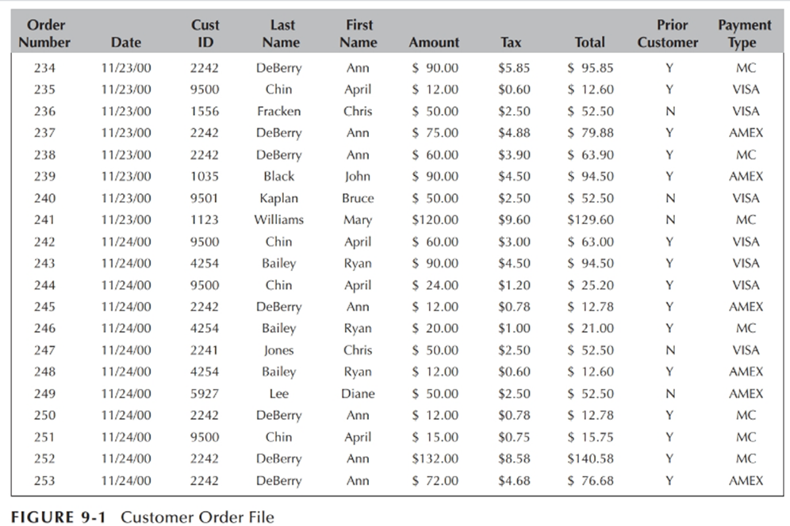

Our table is already in1NF since there is no multivalued attributes
Second normal form:
We remove partial dependencies and have the following
Customers table
Customer_id | Last_name | First_name | Prior-customer | Amount | tax | Total
Orders table:
3.order table
Order-number | Date | Payment-type

Third normal form and BCNF:
We remove transitive dependency for non-prime attributes
- customers details Table
Customer_id is the primary key and Total the foreign key
Customer_id | Last_name | First_name | Prior-customer | Total

2.Total table
Total | Amount | tax

3.order table
Order-number | Date | Payment-type

c)[ 10 points] Briefly explain about multi-valued dependency, and higher normal forms (e.g. 4th normal form)
multi-valued dependency:
occurs when two attributes in a table do not depend each other, but the both depend on the third attribute
example

suppose different car manufactures produce different with 2 colors (white, black) of each model every month.
Car_model | Color | Month_produced
Subaru | White | January
Subaru | White | January
BMW | Black | may
BMW | White | may

Here column color and Month_produced are dependent on car_model and independent of each other
Hence, we can say color and Month_produced columns are multivalued dependent on Car_model
Car_model $→→$ color
Car_model $→→$ Month_produced
higher normal forms (Fourth normal form)
it’s a level of database normalization where there are no non-trivial multivalued dependencies other than candidate key. In addition of database meeting requirement of BCNF, it must not contain more than one multivalued dependency

Q3: [ 50 points] Data stores and indexing

- [15 points] What do you mean by database indexing? Write some SQL commends to index using B+- tree, and for hashing, encryption, and compression functions.
database indexing: it is data structure technique which allows user to retrieve records from a database file quickly.
SQL commends to index using B+- tree:
//creating single column index
CREATE INDEX indexname ON tablename
//creating unique index
CREATE UNIQUE INDEX indexname ON tablename
SQL commends for hashing, encryption
SELECT HASHBYTES (‘MD5’, ‘string to be converted to hash’) As COL1.HASHBYTES (‘MD5’, ‘string to be converted to hash’) as COL2 GO
SQL commends for compression functions
SELECT COMPRESS (‘compressing function’) AS compressed-value
- [20 points] A PARTS file with Part# as the key field includes records with the following Part# values: 20, 69, 37, 61, 47, 92, 48, 71, 56, 59, 18, 21, 10, 74, 78, 15, 16, 20, 24, 28, 39, 43, 47, 50, 69, 75, 8, 41, 33, 38. Suppose that the search field values are inserted in the given order in a B+-tree of order pleaf = 4; Try to show how the tree will expand. What the final tree will look like (extra!). [ Hints you can use visualization tool mentioned in lecture slide]
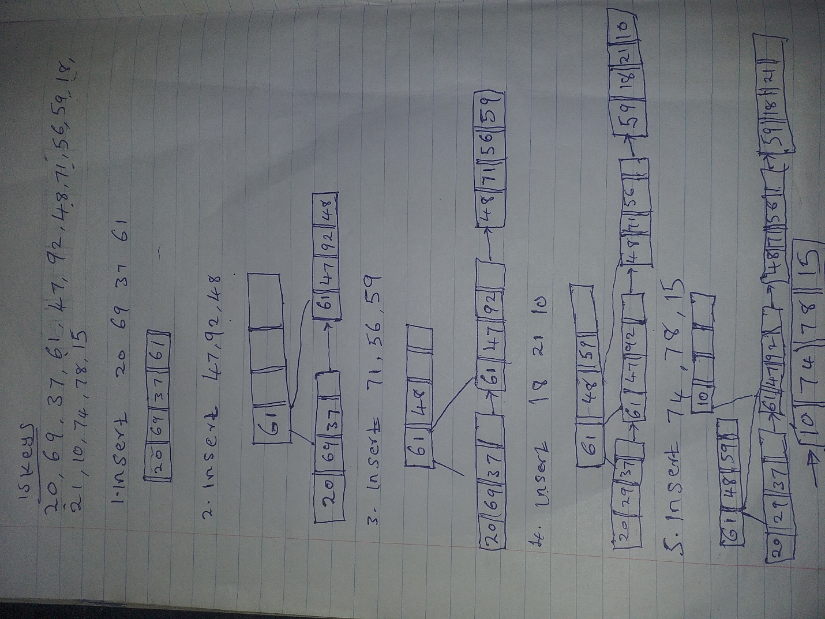

c. [15 points] Compare different indexing techniques based on their advantages and disadvantages.

Unique indexes like primary key and unique constraints prevent duplicate data from entering the table and also might slow down inserts as machine need to compute and enforce the uniqueness
Clustered index, its underlying data might require sorting which may lead to fragmentation on the over-all database while non-clustered indexes take up additional space, that may not be on the same page as the data requested
With dense indexing technique consumes much space (storage) as compared to sparse index techniques though it facilitate faster search.
SQL indexes reduces performance in insert, update and delete queries
Q4. [50 points] Database Transactions Processing
- [15 points] What do we mean by a serializable schedule in a database transactions processing? Or, “Serializable schedule of n transactions is equivalent to some serial schedules of same n transactions” – explain with an example
serializable schedule refers to the schedule whose effects in any consistent database instance is taken to be identical or similar to that of some complete serial schedules.
Example
given transactions T1, T2, T3, T4 and K(i) L(i) as their equivalent transactions we can easily determine if the schedule is serializable or not.

i).
T1 | T2
K (1)
L (1)
 | K (2)
 | L (2)
K (3)
L (3)
Commit
 | commit

In this instance schedule is serializable. This is because the pair of transactions do not have operation on the same data item.
T1 | T2
K (1)
L (1)
 | K (2)
 | L (2)
 | commit
K (2)
L (2)
Commit
ii).

In this example schedule is serializable. because the pair of transactions is equivalent to the serial schedule T2, T1. Hence the results are as well identical to T2 running to completion then T1.

T1 | T2
K (1)
 | K (2)
L (1)
 | L (2)
 | commit
K (2)
L (2)
Commit
iii).

In this schedule example is also serializable. It’s Still equivalent to the serial schedule T2 T1

T1 | T2
K (1)
L (1)
 | K (1)
 | L (1)
 | K (2)
 | L (2)
 | commit
K (2)
L (2)
Commit
iv).

This schedule is not serializable. Both T2,T1 and T1,T2 is not schedule because,T2 IS Reading the results of T1’s write and T1 Is Reading the results of T2’s write respectively.

- [ 20 points] Consider the three transactions T1, T2, and T3 and four schedules S1, S2, S3, and S4 as below. Which of the following schedules is (conflict) serializable? For each serializable schedule, determine draw the precedence graph. [ Hints : you can use the software referred in the lecture slide]
S1: r1(X); r3(X); w1(X); r2(X); w3(X);

T1

T2
T3

S2: r1(X); r3(X); w3(X); w1(X); r2(X);

T1

T3
T2

S3: r3(X); r2(X); w3(X); r1(X); w1(X);

T3
T1
T2

S4: r3(X); r2(X); r1(X); w3(X); w2(X);

T3

T1
T2

S1 AND S2 ARE SCHEDULE SERIALIZABLE WHEREAS, S3 AND S4 SCHEDULE ARE CONFLICTING .

C. [ 15 points] Write at least five points on the importance of transactions processing in a business databases? Also, Briefly explain how to implement a database transaction processing using SQL? [ Hints : see from https://www.geeksforgeeks.org/sql-transactions/]
Importance of transactions processing
ATOMICITY
Transaction processing paves way for two identical transaction to occur at the same time. Thus, if one fails the other cannot occur either
CONSISTENCY
Consistency in transaction processing allows the database to inspect a checking account to allow no duplicate check number.
ISOLATION
This explains that, there exist isolation between concurrent transaction involving withdrawal transaction and from the same business account. isolation thus allows new balance feedback to every successful withdrawal transacts committed.
DURABILITY
Transaction processing in business database is beneficial basing on how long it can allow multiple concurrent transaction regardless of other condition. That is, two transaction events can occur simultaneously event if the system experiences hardware failure or software failure.
DATA INTEGRITY
element a database transaction processing using SQL

The following sql statements solely explains how transaction processing is implemented using SQL.
i). BEGINNING TRANSACTION, this shows, the starting point of transaction.
Sql statement: BEGIN TRANSACTION deposit;

ii). SET TRANSACTION, here a name is placed on the transaction to be processed as either read only or write only
Sql statement: SET TRANSACTION write-only;

ii). COMMIT-in this step everything is in the required format, all information are within a single transaction. Hence all statements are saved together in the database.
iv). ROLLBACK TRANSACTION, Implies a transaction is explicitly closed and any post transaction after closure is denied.

Q5. [50 points] OODB, NoSQL, MongoDB

- [ 20 points] Write the similarities and differences in SQL implementation of an OO schema for a database application and the traditional database implementation (you can consider the UNIVERITY database as an example). [ Hints: You can explain, how to construct an EER schema for the application, and then create the corresponding classes in ODL. Specify a number of methods for each class, and then specify queries in OQL for your database application, etc.]
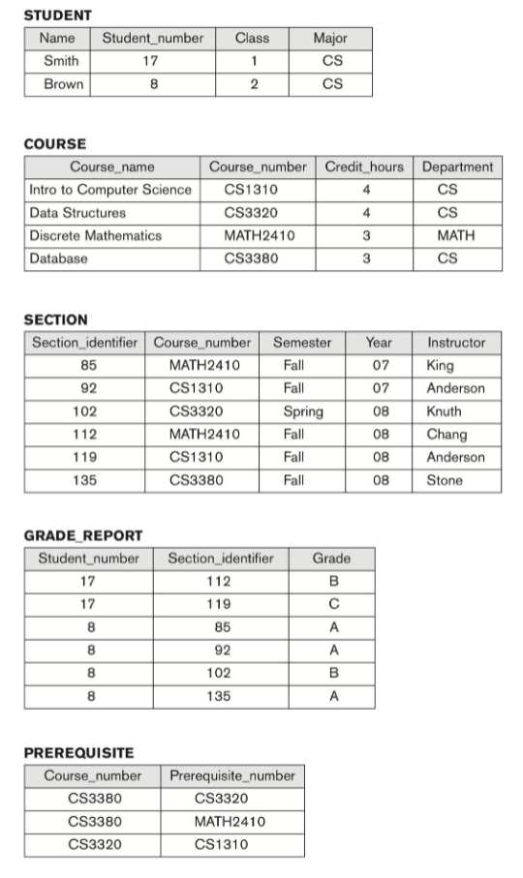
similarities in SQL implementation
They both have existence dependency
The university database have several tables whose entity exists in relation to one another. Basing, On the university database grade report exists as a result of student.

Associations can be easily noted out
Thus, entities of different type can be identified and associated with one another. Department entity in the course table owns the student in the student tables

Categorization
Number of entities can be grouped and sub grouped to a common group. Entities’ stated in the university tables can be grouped further to form the major university database.

an EER Schema for the database application has the constraints to be kept in the database and it must have several entity types, relationships and both weak and strong entity as well.

ODL classes. For all the tables in the university database.
This ODB classes explains how the corresponding classes are created with a number of specified OQL for each.
ODL CLASS FOR TABLE STUDENT
Class<STUDENT> {
Attribute String Name;
Attribute int Student_number;
Attribute int Class;
Attribute string Major;

}
OQL FOR TABLE STUDENT
Select distinct S.name
FROM STUDENT S
Where S. Class = ”2” ;

ODL CLASS FOR TABLE COURSE

Class<COURSE> {
Attribute String Course_name;
Attribute int Course_number;
Attribute int Credit_hours;
Attribute string Department;

}

OQL FOR TABLE COURSE
Select *
FROM COURSE C
Where C. Credit_hours = ”2”

ODL CLASS FOR TABLE SECTION
Class<SECTION> {
Attribute int Section_identifier;
Attribute int Course_number;
Attribute string Semester;
Attribute int Year;
Attribute string Instructor;

}

OQL FOR TABLE SECTION
Select Course_number, Section_number
FROM SECTION;

Class<GRADE REPORT> {
Attribute int Section_identifier;
Attribute int Student_number;
Attribute string Grade;

}

Class<PREREQUISITE> {
Attribute int Course_number;
Attribute int Prerequisite_number;
}
There are several methods that can be obtained from the database tables, as shown below
    - Class STUDENT (Student_number, name) {…………….} for student table
    - getCourse (course_name, course_id) {………………} for COURSE table
    - setGradeReport (Student_number, Grade) {……….} for GRADE_REPORT

- [20 points] What are advantages of using NoSQL database? Name some industries (five) who adopted the No SQL database environment. Explain the MongoDB data model with an example.

advantages of using NoSQL database
Handle large volume of data at high.
NoSQL, provides a clearly path intended to enhance scalability when data volume or data traffics grows.
Enables easy updates to schema.
NoSQL stores information in an-easy-to-understand forms and it allows developers to edit directly the structure of the data (logical schema).
Developer-friendly,
NoSQL is developer friendly, as it involves minimal transformations when its data is exported or imported from or to the database respectively.
Delivers zero downtime.
NoSQl databases have upgrades and their schema can be changed with zero downtime.
Industries (five) who adopted the No SQL database environment
Companies that use NoSQL includes; Qualcom, Capgemini, Adobe, J.P Morgan, and Amazon

MongoDB data model
MongoDB Is an object-oriented database, it’s simple dynamic and it’s a scalable NoSQL. Database.
It largely employs NoSQL document store model. Individual databases have collection which has documents in return. The document explains further on how developers construct their classes and objects given a certain programming language. Documents in mongoDB does not need any schema to be populated. MongoDB scalability is superb as it allows storage of many documents it.
Example
_ID: <item_Id>,
FirstName: I am Innocent,
Own: {
Item_ID:234
SecondName: Creature
Items:20
}
Explanation
_ID refers to the require field in mongoDB document.
Collection in mongoDB is equated to the database tables and it involves document grouping.

- [10 points] Can we run query efficiently in MongoDB? Give an example.

Yes, we can efficiently run query in mongoDB. In MongoDB, indexes are created to support Queries. Query result are as well limited to Reduce several demands in network. Indexes are used in query because they can be scanned faster. Index scanning does not consume time compared to collection scanning.
Examples
Query for a post collection with blog posts. To sort an editor regularly on the editor_name field then the query can be optimized,
db.posts.createIndex( { editor_name : 1 } )
1, is the index, indexes improves efficiency of queries that are sorted on a given field.

Creating index for Query that sorts on the timestamp field
db.posts.createIndex( { timestamp : 1 }

queries in mongoDB that can read indexes:
db.posts.find().sort({timestamp: -1})
mongoDB reads indexes in ascending and descending order irrespective of the direction of single-key index.
Limiting queries in mongoDB
db.posts.find().sort({timestamp: -1}).limit(30)
in mongoDB this sql statement will output 30 sorted results.

[ Hints : for mongoDB see document and links in the test/final folder]

Q6. [50 points] Distributed DB, Big-Data, MongoDB, Block chain
- [ 15 points] The Clustrix Database is a distributed database built from the ground up to be a MySQL replacement. It has a shared nothing architecture and automatically distributes data and does distributed query evaluation. Based on Clustrix as an example, briefly explain how to build a A Distributed database, refers to a wide collection of more than one interconnected database systems that are physically situated in different location through computer internet connectivity.
ClustrixDB distributes data sets across a large number of independent nodes, as well as provides reasoning behind some of our architectural decisions.
Distributed database based on clustrix
Sql syntax to create table clustrix.
Sql > CREATE TABLE clustrix (
ID bigint,
Age integer,
Month varchar(20);
Key k1 (age),
Key k2 (day, ID),
primary key(ID)
);

Population the table (table name clustrix)

Table: clustrix
ID | age | day | month
1 | 18 | 10 | december
2 | 20 | 21 | february
3 | 30 | 32 | march
4 | 35 | 44 | april
5 | 50 | 38 | may

Representation

Table: clustrix
base representation | k1 representation | k2 representation
primary key | index (age) | index (month, age)
  ID | age | day | month
  1 | 18 | 10 | december
  2 | 20 | 21 | february
  3 | 30 | 32 | march
  4 | 35 | 44 | april
  5 | 50 | 38 | may
  age | id
  38 | 5
  44 | 4
  32 | 3
  21 | 2
  10 | 1
  month | age | ID
  april | 35 | 4
  february | 20 | 2
  december | 18 | 1
  march | 30 | 3
  may | 50 | 5

base representation slices
slice 1 |  | slice 2 |  | slice 3
  ID | age | day | month
  2 | 20 | 21 | february
  4 | 35 | 44 | april
  ID | age | day | Month
  1 | 18 | 10 | december
  5 | 50 | 38 | May
  ID | age | day | month
  3 | 30 | 32 | march
k1 representation
slice 1 | slice 2
  day | ID
  38 | 5
  32 | 3
  21 | 2
  day | ID
  44 | 4
  10 | 1

k2 representation
slice 1 | slice 2 | slice 3 | slice 4
  month | day | ID
  april | 44 | 4
  month | day | ID
  february | 21 | 2
  month | day | ID
  december | 10 | 1
  march | 32 | 3
  month | day | ID
  may | 38 | 5

- [15 points] Map and Reduce automatically parallelize and executes on large clusters of commodity hardware. Briefly explain the MapReduce programming model with an example.
[ Hints: see lecture slide]
Map Reduce
MapReduce model, processes huge amounts of data and it works in two vital phases map and reduce.
Map is tasked with decomposition and mapping of information whiles reduce is tasked with shuffling and reduction of data.

In map reduce programming the developer needs to specify functions associated with mapping (map function) and those associated with reduction (reduce function). Thus, the respective inputs at map and reduce phase are key-value pairs.

MapReduce splits inputted se of data into independent chunks to be processed by the map tasks in a solely manner that is in parallel.

Map reduce programming plays a vital role in cloud computing field. This is because, they are vital in large scale data analysis performance in collaboration with multiple machines in clusters.
MapReduce, is a processing technique and a model for distributed computing based on java.

Large scale data clusters in MapReduce programming are undertaken through four phases, namely; mapping, reducing, shuffling and splitting. Splitting refers to decomposition of fixed-size pieces (splits)splits, are inputs consumed by a single map. Mapping counts number of occurrences of individual words from splits and create a list in the form of <word, frequency>.
Reducing combines values from Shuffling phase and returns a single output value.

- [20 points] What is a block chain technology? How does the blockchain technology upending data transaction processing only as secure as its infrastructure? Explain with an example.
Block chain technology
Blockchain technology refers to a system of recording facts and figures in a manner that renders the data harder to be negatively exploited and impossible to edit, hack, or manipulate the system with the information.
A blockchain also acts as a digital ledger of transactions that can be of several copies and distributed across networked computer systems that takes part on the blockchain technology,
Therefore, blockchain technology is the technology that deals with the digital record of information transactions. It can be used to create a permanent, public, digitalized ledger system accessible to all members of the public for gathering, grouping and sorting data on sales, keeping track on digital use and as a mode of paying the content creators through wireless means.

Block chain Security
Block chain technology allows data transaction security enhanced through cryptography. Cryptography explains that, Each transaction to be signed with a private key and be verified with a public key. If the data to be transacted changes, the signature becomes unaccepted. Finally, the respective block of information will be ignored and it will not thrive in the blockchain.
Several technology relies on block chain technology like Government, trading and marketing applications in health services.

Block chain technology is considered as the distributed ledger technology, with ledger arranged in a systematic chain of information blocks, Blocks are signed by the expert behind it and it constitutes a chain through pointer to the earlier block; the header of the respective blocks has a cryptographic hash of the earlier block that guarantees block linking.

Blockchain constitutes a permission-free blockchain where all individuals involved in the network keeps a duplicate of the ledger while in permission required blockchain, different ledgers are kept by a completely different individual groups.

For instance, the Hyperledger Fabric is a permissioned-required blockchain technology which prompts one to the different copy of information to different channels, this positively impacts the security of the data to be transacted however ledger synchronization negatively affects the permission-required block chain.
Consensus mechanisms are amongst the security mitigations employed in this technology to guarantee secure data transaction processing. This mechanisms are guided by how participants store and verify blocks of information agreed based on truth. The Consensus, allows nodes validate blocks of data in the computer system over an internet .

Proof of work ( PoW ) is a consensus mechanism for verification applied in Bitcoin and Ethereum. Proof of work majors on block insertion in the respective chain. Hashes, guarantees data security as its used as a verification tool as well. Hashes, verifies data integrity and cryptography signature process.

